Practice 6

1. The HR department needs a query that prompts users for an employee last name. The query then displays the last name and hire date of any employee in the same department as the employee whose name they supply (excluding that employee). For example, if the user enters Zlotkey, find all employees who work with Zlotkey (excluding Zlotkey).



1. Create a report that displays the employee number, last name, and salary of all employees who earn more than the average salary. Sort the results in ascending order by salary.

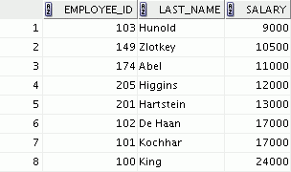

1. Write a query that displays the employee number and last name of all employees who work in a department with any employee whose last name contains a *u*. Place your SQL statement in a text file named lab_06_03.sql. Run your query.

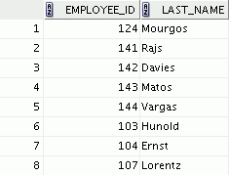

Practice 6 (continued)

1. The HR department needs a report that displays the last name, department number, and job ID of all employees whose department location ID is 1700.

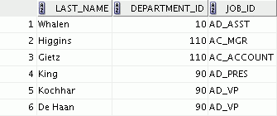

Modify the query so that users are prompted for a location ID. Save this to a file named

lab_06_04.sql.

1. Create a report for the HR department that displays the last name and salary of every employee who reports to King.

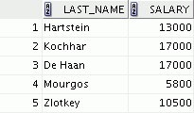

1. Create a report for the HR department that displays the department number, last name, and job ID for every employee in the Executive department.

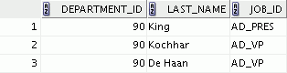

If you have time, complete the following exercise:

1. Modify the query in lab_06_03.sql to display the employee number, last name, and salary of all the employees who earn more than the average salary and who work in a department with any employee whose last name contains a *u*. Resave lab_06_03.sql as lab_06_07.sql. Run the statement in lab_06_07.sql.

